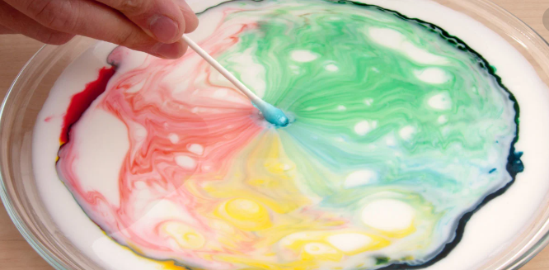
Adults!
The simple scientific explanation behind this experiment is that the soap attaches to the fat in the milk – forcing the food colouring to get pushed to the sides!

Before giving this answer away – encourage your children to think scientifically and share their ideas. How do they think this is happening? Can you guide them to the answer so that they figure it for themselves?

Potential question: Why does it stop?
Answer: As most of the soap attaches to the fat in the milk and the soap spreads throughout the milk, the colour explosion will slow and eventually stop.

