 | Medication Request Form | 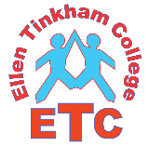
Staff at Ellen Tinkham School or Ellen Tinkham College will not give your child any medication unless you complete and sign this form.

STUDENT NAME:
DATE OF BIRTH:
ALLERGIES:

Medication & strength | Time | Dose | Full directions for use

I understand that I must inform the transport escort that medicines are being transported to school.
I consent to the school nursing staff or school staff giving the above medication to my child
Name |  | Date
Signature
Relationship to Pupil

